ST. XAVIER’S COLLEGE

**(Affiliated to Tribhuvan University)**

Maitighar, Kathmandu



**Simulation and Modeling Assignment #1**

**Submitted by**

**Pradeep Dahal**

017BSCIT029

**Submitted to**

Ganesh Yogi

**Department of Computer Science**

**Maitighar, Kathmandu, Nepal**

**November, 2019**

**Markov Chain**

A **Markov chain** is a mathematical system that experiences transitions from one state to another according to certain [probabilistic](https://brilliant.org/wiki/probability-rule-of-product/) rules. The defining characteristic of a Markov chain is that no matter how the [process](https://brilliant.org/wiki/stochastic-processes/) arrived at its present state, the possible future states are fixed. In other words, the probability of transitioning to any particular state is dependent solely on the current state and time elapsed. The **state space**, or set of all possible states, can be anything: letters, numbers, weather conditions, baseball scores, or stock performances.

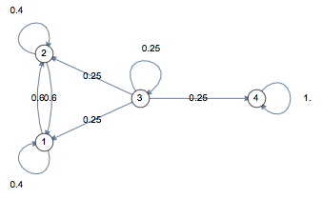

**A Business Case**

**A simple business case**

Coke and Pepsi are the only companies in country X. A soda company wants to tie up with one of these competitor. They hire a market research company to find which of the brand will have a higher market share after 1 month. Currently, Pepsi owns 55% and Coke owns 45% of market share. Following are the conclusions drawn out by the market research company:

P(P->P): Probability of a customer staying with the brand Pepsi over a month = 0.7

P(P->C): Probability of a customer switching from Pepsi to Coke over a month = 0.3

P(C->C): Probability of a customer staying with the brand Coke over a month = 0.9

P(C->P): Probability of a customer switching from Coke to Pepsi over a month = 0.1

We can clearly see customer tend to stick with Coke but Coke currently has a lower wallet share. Hence, we cannot be sure on the recommendation without making some transition calculations.

**Transition diagram**

The four statements made by the research company can be structured in a simple transition diagram.

[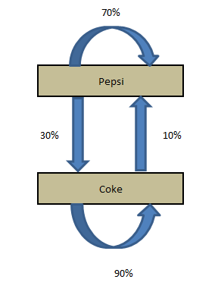](https://www.analyticsvidhya.com/blog/wp-content/uploads/2014/07/transition.png)

The diagram simply shows the transitions and the current market share. Now, if we want to calculate the market share after a month, we need to do following calculations:

Market share (t+1) of Pepsi = Current market Share of Pepsi * P(P->P) + Current market Share of Coke * P(C->P)

Market share (t+1) of Coke = Current market Share of Coke * P(C->C) + Current market Share of Pepsi * P(P->C)

These calculations can be simply done by looking at the following matrix multiplication:

Current State X Transition Matrix = Final State

[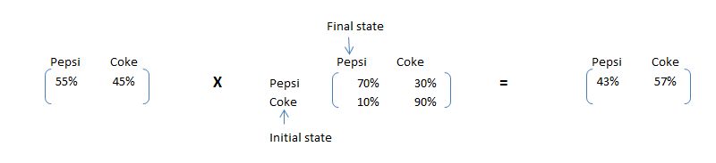](https://www.analyticsvidhya.com/blog/wp-content/uploads/2014/07/trans1.png)

As we can see clearly see that Pepsi, although has a higher market share now, will have a lower market share after one month. This simple calculation is called Markov chain. If the transition matrix does not change with time, we can predict the market share at any future time point. Let’s make the same calculation for 2 months later.

[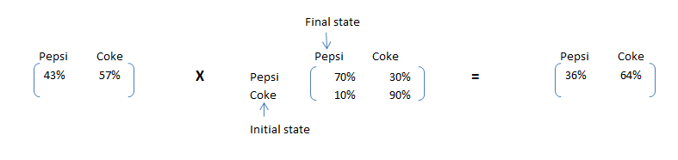](https://www.analyticsvidhya.com/blog/wp-content/uploads/2014/07/trans2.png)

 Steady state Calculations

Furthermore, to the business case in hand, the soda company wants to size the gap in market share of the company Coke and Pepsi in a long run. This will help them frame the right costing strategy while pitching to Coke. The share of Pepsi will keep on going down till a point the number of customer leaving Pepsi and number of customers adapting Pepsi is same. Hence, we need to satisfy following conditions to find the steady state proportions:

Pepsi MS * 30% = Coke MS * 10% …………………………………………….1

Pepsi MS + Coke MS = 100% ……………………………………………………2

4 * Pepsi MS = 100% => Pepsi MS = 25% and Coke MS = 75%

Let’s formulate an algorithm to find the steady state. After steady state, multiplication of Initial state with transition matrix will give initial state itself. Hence, the matrix which can satisfy following condition will be the final proportions:

Initial state X Transition Matrix = Initial state